|  |  |
| --- | --- |
| **Ex.** 5 | **OPERATIONS ON ARRAY LIST** |
| **Date:** 16-08-2024 | |

**AIM:**

To create a Java program to perform string operations using an ArrayList.

**ALGORITHM:**

1. Create an instance of the methods class and a Scanner for user input.
2. Display the menu and prompt the user for a choice.
3. Based on the input, perform the required operation on the ArrayList.

**PROGRAM:**

package Lab5;

import java.util.*;

public class methods {

ArrayList<String> list = new ArrayList<String>();

// Method to Append a String

public void append(String value) {

list.add(value);

}

// Method to Insert a String at Any Valid Position

public int insertAtPosition(String value, int position) {

if (position > list.size()) {

return 0;

}

list.add(position, value);

return 1;

}

// Method to search the String

public boolean search(String value) {

return list.contains(value);

}

// Method to Display All Elements Starting in the Character

public void displayElementsStartingWith(char value) {

for (String i : list) {

if (i.charAt(0) == value) {

System.out.println(i);

}

}

}

// Method to Sort Elements in Ascending Order

public void ascendingSort() {

Collections.sort(list);

}

// Method to Sort Elements in Descending Order

public void descendingSort() {

Collections.sort(list, Collections.reverseOrder());

}

// Method to Display all Elements

public void displayElements() {

for (String i : list) {

System.out.println(i);

}

}

}

// Main Class

package Lab5;

import java.util.*;

public class lab5 {

// Main Method

public static void main(String[] args) {

methods operations = new methods();

Scanner input = new Scanner(System.in);

String val;

boolean loopController = true;

while (loopController) {

System.out.println("Hello!");

System.out.println("1. Append");

System.out.println("2. Insert at Particular Index");

System.out.println("3. Search");

System.out.println("4. List All Strings Starting With The Given Letter");

System.out.println("5. Sort");

System.out.println("6. Display all Elements");

System.out.println("7. Exit");

int choice = input.nextInt();

switch (choice) {

case 1:

System.out.println("Enter the String to Append:");

val = input.next();

operations.append(val);

System.out.println("Insertion Successful.");

break;

case 2:

System.out.println("Enter the String to Add:");

val = input.next();

System.out.println("Enter the Position (Zero Index Based):");

int position = input.nextInt();

int flag = operations.insertAtPosition(val, position);

if (flag == 0) {

System.out.println("Error while Inserting Value.");

} else {

System.out.println("Insertion Successful.");

}

break;

case 3:

System.out.println("Enter the String to Search:");

val = input.next();

if (operations.search(val))

System.out.println("String Found in List.");

else

System.out.println("String Not Found in List");

break;

case 4:

System.out.println("Enter the Character to Search:");

char character = input.next().charAt(0);

operations.displayElementsStartingWith(character);

break;

case 5:

System.out.println("Enter:\n1. Ascending Order");

System.out.println("2. Descending Order");

int orderChoice = input.nextInt();

switch (orderChoice) {

case 1:

operations.ascendingSort();

System.out.println("Ascending Sort Successful.");

break;

case 2:

operations.descendingSort();

System.out.println("Descending Sort Successful.");

break;

default:

System.out.println("Invalid Input..");

break;

}

break;

case 6:

operations.displayElements();

break;

case 7:

System.out.println("Exiting...");

loopController = false;

break;

default:

System.out.println("Invalid Input..");

break;

}

}

}

}

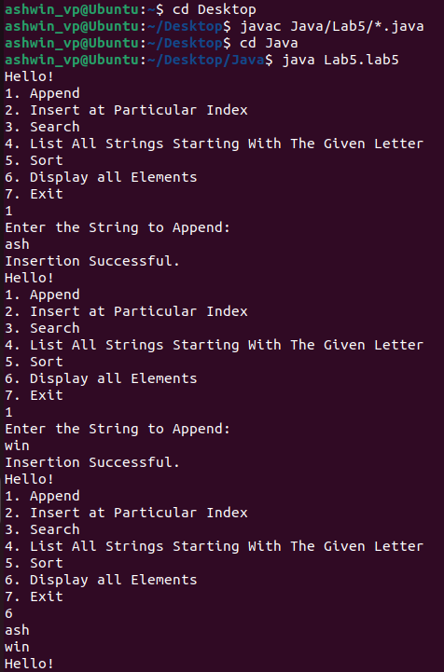**OUTPUT:**

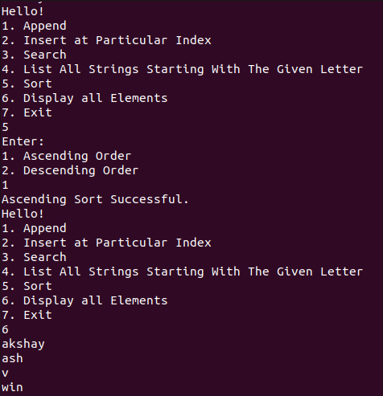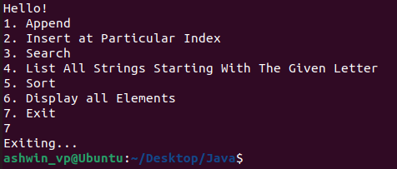

**RESULT:**

Thus, a Java Application to perform operations on an ArrayList has be created.